Experiments (8 to 21)
Name:M.Raja Manohar Reddy
Reg.no:192325062
8. Generate random numbers from a normal distribution; count occurrences.
x <- rnorm(1000, mean = 0, sd = 1)
summary(x)
table(cut(x, breaks=5))
output
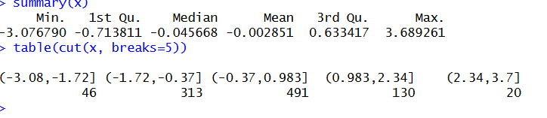

9. Create empty plots with specified axis limits.
plot(1, type="n", xlim=c(0,100), ylim=c(0,50),
xlab="X-axis", ylab="Y-axis",
main="Empty Plot")

Output
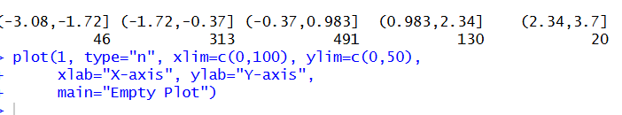

10. 10. Create and explore a data frame exam_data with name, score, attempts, and qualify fields. Perform extract, add row/column, sort, save to file.
exam_data <- data.frame(
name=c("A","B","C","D","E"),
score=c(90,85,88,92,75),
attempts=c(1,2,1,3,2),
qualify=c("yes","yes","yes","yes","no")
)
print(exam_data)
exam_data[1:3,]
exam_data$grade <- c("A","B","B","A","C")
exam_data <- rbind(exam_data, data.frame(name="F",score=80,attempts=1,qualify="yes",grade="B"))
exam_data <- exam_data[order(-exam_data$score),]
write.csv(exam_data,"exam_data.csv",row.names=FALSE)
output
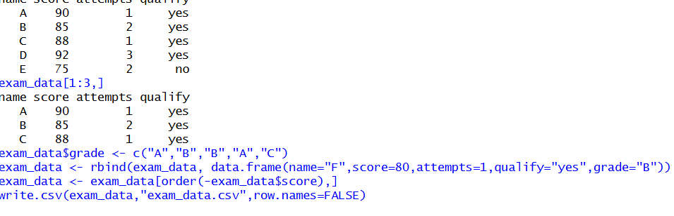

11. Write an R program to read a .csv file and display contents.
data <- read.csv("exam_data.csv")
print(data)
output
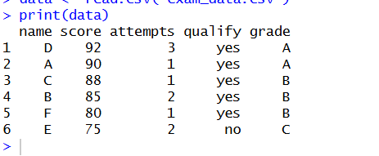
12. Perform data reshaping on airquality dataset: melt, cast, compute monthly averages for Ozone, Solar.R, Wind, and Temperature.
library(reshape2)
data(airquality)
melted <- melt(airquality, id.vars=c("Month","Day"))
casted <- dcast(melted, Month ~ variable, mean, na.rm=TRUE)
print(casted)
output

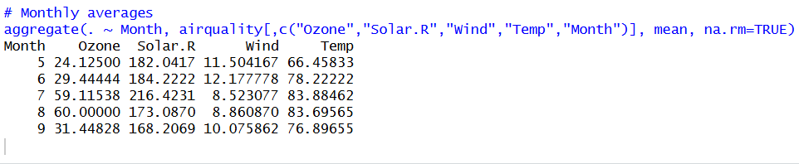

13. Combine multiple arrays row-wise.
data(iris)
dim(iris)
summary(iris)
apply(iris[,1:4],2,sd)
apply(iris[,1:4],2,quantile)
aggregate(.~Species,data=iris,mean)
iris$SepalCat <- cut(iris$Sepal.Length,breaks=3,labels=c("Low","Medium","High"))
table(iris$SepalCat,iris$Species)
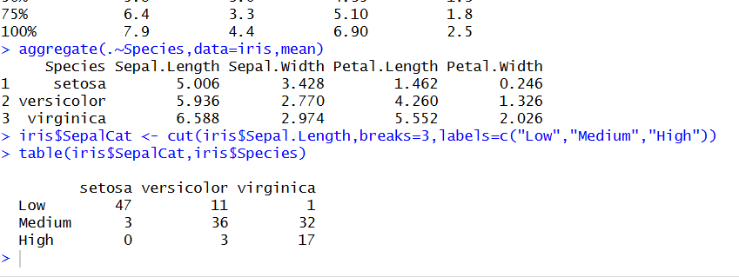
14. Explore and manipulate ChickWeight dataset (sorting, melting, casting by Diet).
data(USArrests)
summary(USArrests)
rownames(USArrests)[which.max(USArrests$Rape)]
max(USArrests$Murder)
min(USArrests$Murder)
cor(USArrests)
USArrests[USArrests$Assault>median(USArrests$Assault) & USArrests$Murder<quantile(USArrests$Murder,0.25),]
hist(USArrests$Murder)
plot(density(USArrests$Assault))
plot(USArrests$Murder,USArrests$Assault)
barplot(USArrests$Murder)
output
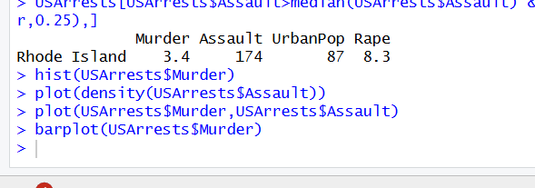
15. Perform EDA on iris dataset: dimensions, summary, standard deviation, quantiles, grouping by
data(iris)
dim(iris)
summary(iris)
sd(iris$Sepal.Length)
quantile(iris$Sepal.Length)
aggregate(. ~ Species, iris, mean)
# Category grouping
iris$Category <- ifelse(iris$Sepal.Length > 6, "High", "Low")
table(iris$Category)
output
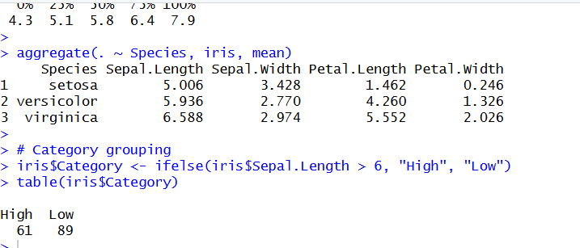

16.Explore USArrests dataset: summary statistics, state with largest rape arrests, max & min murder rates, correlation among features, states above median assault arrests and bottom 25% for murder, visualization with histogram, density, scatterplots, bar graphs.
PROGRAM:
# Load dataset
data(USArrests)

# Summary statistics
summary(USArrests)

# State with largest Rape arrests
rownames(USArrests)[which.max(USArrests$Rape)]

# Max & Min Murder rates
max(USArrests$Murder)
min(USArrests$Murder)

# Correlation among features
cor(USArrests)

# States above median Assault
median_assault <- median(USArrests$Assault)

USArrests[USArrests$Assault > median_assault, ]

# Bottom 25% Murder
q1 <- quantile(USArrests$Murder,0.25)

USArrests[USArrests$Murder <= q1, ]

# Histogram
hist(USArrests$Murder,
main="Histogram of Murder",
xlab="Murder Rate")

# Density plot
plot(density(USArrests$Murder),
main="Density Plot")

# Scatterplot
plot(USArrests$Murder,
USArrests$Assault,
main="Murder vs Assault",
xlab="Murder",
ylab="Assault")

# Bar graph
barplot(USArrests$Murder,
main="Murder Rates by State",
las=2)

OUTPUT:
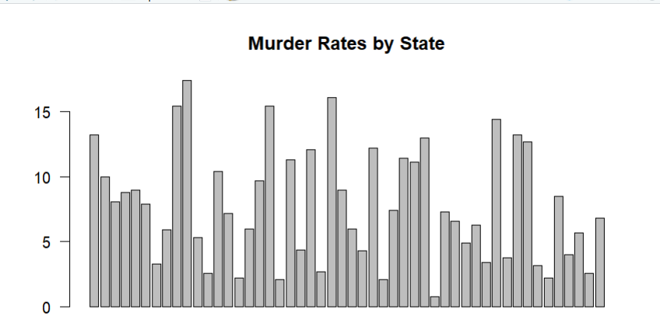

17. Explore Titanic dataset: bar chart of survival vs class, modify plot by gender, histogram of Age.
PROGRAM:
# Load dataset
data(Titanic)

titanic_df <- as.data.frame(Titanic)

# Survival vs Class
barplot(table(titanic_df$Survived,
titanic_df$Class),
beside=TRUE,
legend=TRUE,
main="Survival vs Class")

# Survival by Gender
barplot(table(titanic_df$Survived,
titanic_df$Sex),
beside=TRUE,
legend=TRUE,
main="Survival by Gender")

# Histogram of Age
hist(as.numeric(titanic_df$Freq),
main="Histogram of Age",
xlab="Age")

OUTPUT:
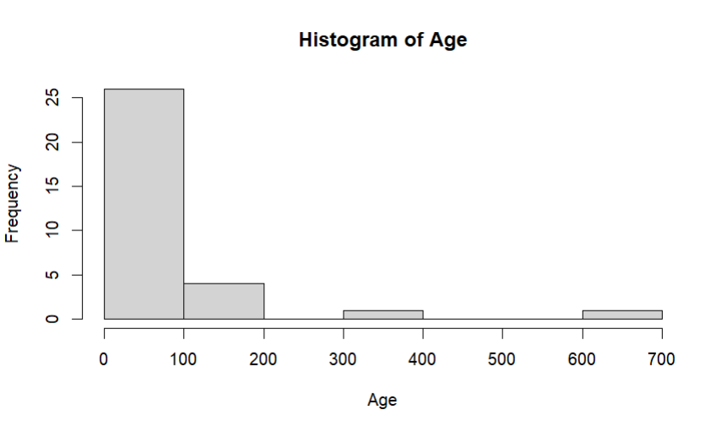

18. Create graphs in R: boxplot, histogram, bar plot, line chart, scatter plot.
PROGRAM:
data(iris)

# Boxplot
boxplot(iris$Sepal.Length,
main="Boxplot")

# Histogram
hist(iris$Sepal.Length,
main="Histogram")

# Bar Plot
barplot(table(iris$Species),
main="Bar Plot")

# Line Chart
plot(iris$Sepal.Length,
type="l",
main="Line Chart")

# Scatter Plot
plot(iris$Sepal.Length,
iris$Petal.Length,
main="Scatter Plot")
OUTPUT:
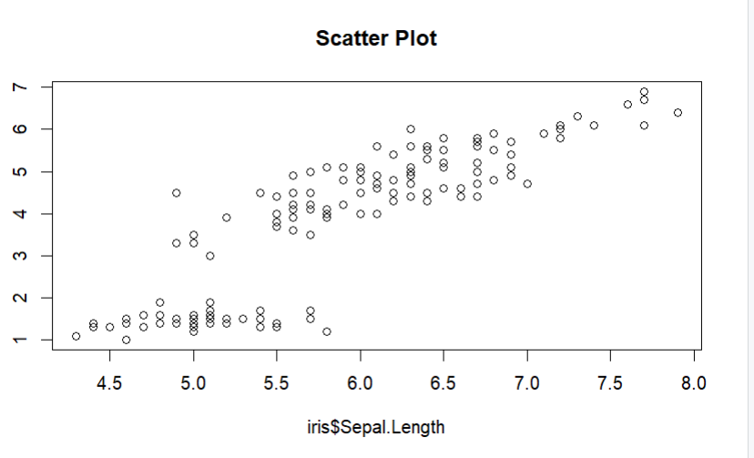
19. Build a regression model on advertising dataset (Sales ~ Spend) and predict Sales.
PROGRAM:
# Create dataset
advertising <- data.frame(
Spend=c(10,20,30,40,50),
Sales=c(12,25,35,45,55)
)

# Build model
model <- lm(Sales ~ Spend,
data=advertising)

summary(model)

# Predict Sales
predict(model,
data.frame(Spend=60))
OUTPUT:
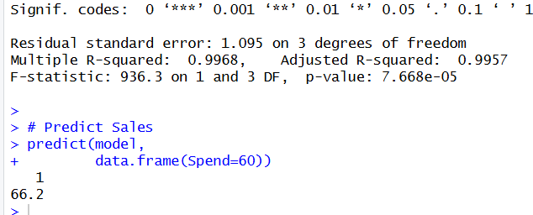
20. Create multiple regression model using ChickWeight dataset with “Time” and “Diet” as predictors; predict weight and compute model error.
PROGRAM:
data(ChickWeight)

# Convert Diet to numeric
ChickWeight$Diet <- as.numeric(ChickWeight$Diet)

# Model
model2 <- lm(weight ~ Time + Diet,
data=ChickWeight)

summary(model2)

# Prediction
pred <- predict(model2)

# Model Error (MSE)
mean((ChickWeight$weight - pred)^2)
OUTPUT:
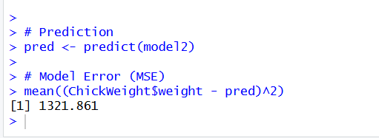
21. Randomly split iris dataset into train/test (80/20), build logistic regression (Species ~ Petal.Length + Petal.Width), predict, and evaluate with confusion matrix.
PROGRAM:
set.seed(1)

data(iris)

# Convert Species to binary
iris$Species <- ifelse(iris$Species=="setosa",1,0)

# Split 80-20
n <- nrow(iris)

index <- sample(1:n,0.8*n)

train <- iris[index,]
test <- iris[-index,]

# Model
model3 <- glm(Species ~ Petal.Length + Petal.Width,
data=train,
family=binomial)

# Prediction
prob <- predict(model3,
test,
type="response")

pred <- ifelse(prob>0.5,1,0)

# Confusion Matrix
table(Predicted=pred,
Actual=test$Species)
OUTPUT:




